Cabinet’s Response to Consultation
  - February 2025

Budget 2025-2026

Statement from the Leader of the Council and Cabinet Member for Finance
In accordance with the Council’s Constitution, the Cabinet is proposing a balanced net Revenue Budget of £147.5 million for 2025/2026 and a 2025/2026 Capital Investment Plan of £32.6 million for the Council’s consideration. As we said when we launched the consultation, our approach in proposing this budget continues to be one of focusing on the ongoing revenue pressures and delivering against our financial sustainability plans and our Capital Investment Plan. As always we want to ensure we concentrate on the things that residents have told us matter to them.
We’d like to thank all of those who provided feedback to the draft proposals through completing our questionnaire and by responding and commenting to our social media posts. We’d also like to thank the Overview and Scrutiny Board for its time in reviewing our proposals and for providing useful observations and suggestions which we have incorporated into these final budget proposals.
It was pleasing to see that the community supported the majority of our original proposals put forward and, in light of the final funding settlement we have been able to take on board many of your responses and suggestions as well as pushing forward with more of our regeneration plans.
Last year we stated that our aim was to take a long term strategic approach in developing our budget. We have reviewed the situation and have sought to strengthen initiatives that were started last year. This is in line with our resident’s requests and help to meet the Council Corporate objectives.
The additional Government funding recently announced for social care will be split equally between adult social care and children’s social care. Funds have been allocated to help manage pressures in the provider market particularly those created by the national increases in employer’s National Insurance. Further funding will support ongoing transformation work in adult services and the strengthening of a number of activities in support of our young people. Details on the initiatives to enhance our social care provision can be found in the Financial Officers report.
There remain concerns that inflationary pressures will persist with many of our suppliers experiencing increased costs as a result of the Government’s autumn budget but we have recognised that in our proposals. We do however welcome the additional funding announced by Government, particularly the £2 million Recovery Grant and this has provided some scope for additional investment. In determining where this could be made, we have taken account of the responses to the consultation, including the views of the Overview and Scrutiny Board, as well as emerging service pressures. The full set of recommendations from the Overview and Scrutiny Board are set out in Appendix 1 together with the Cabinet’s response.
The changes we are proposing to the budget for 2025/2026 are outlined within the Chief Finance Officer Update report but include the following:
- Within the consultation results, we were pleased to see the overwhelming support for our proposed investment in two flagship projects – Operation Brighter Bay and Operation Town Centres. Each of these will benefit from an increased budget of £300,000 next year resulting in an additional funding across the two projects of over a £1million per year compared with the lack of investment seen two years ago.
  - Operation Brighter Bay will see additional investment to help make our Bay safer and more attractive. We will bring forward a new maintenance team to help with additional work in making Torbay the kind of place you want to see and thus, more welcoming to visitors.
  - Operation Town Centres will see further collaboration between local Police Officers and council Staff. The council will be providing additional staff on the streets in our Town Centres with the objective of enabling more enforcement against those who engage in anti-social behaviour as well as providing greater assistance to individuals who need our help and support.
- The allocation of £150,000 to increase support for events in Torbay. This will not only ensure that our Events Team are able to build on the success of much valued events such as the ‘Bay of Lights’ but will also enable our newly appointed Town Centres Manager to significantly improve the events offer across all three towns.
- The allocation of £1.4 million to support council led Housing Developments to increase the level of affordable housing across the Bay. This will supplement initiatives already underway through our £6 million ‘Hotels to Homes schemes’ and through our Town Centre Regeneration projects.
- £500,000 funding to make a meaningful start on the refurbishment of Play Parks in Torbay. Expenditure will be allocated with reference to priorities identified in the Play Park Strategy.
- The allocation of £200,000 to support a Community Grant Fund. This will allow the council to work alongside Community Groups to undertake and fund projects suggested by the Community in the most deprived wards in Torbay. Criteria for this fund will be determined over the next two months, but these are likely to favour initiatives that have lasting benefit to residents in Torbay.
- A small £500 increase in the size of each Councillor’s Ward Fund allowing all wards in Torbay to benefit from new funding.
We stated in our Draft Budget that we hoped to be able to set a balanced budget without increasing Council Tax to the full extent permitted by Government. We have considered your wish that the council improves its services against the requirement to set a balanced budget, however we have also considered the pressures that many households are facing and are able to confirm that we are recommending a, beneath maximum, increase of 4.75%
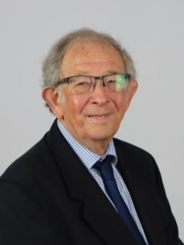
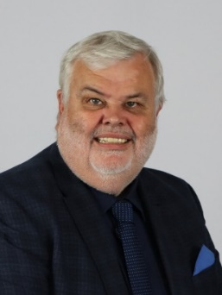

Councillor David Thomas Councillor Alan Tyerman
Leader of Torbay Council Cabinet Member for Housing and Finance

Appendix 1 – Cabinet’s response to the recommendations of the Overview and Scrutiny Board
Recommendations from the Overview and Scrutiny Board | Cabinet’s Response
- That £75,000 Revenue funding be included in the base budget to support sport in 2025/26 and future years. | The £75,000 previously supported from the Public Health budget is now proposed to be included in the base budget.
- That a Reserve of £500,000 be created for play parks. | £500,000 from the additional one-off funding received is proposed to be allocated to a Reserve to invest in the council’s existing play parks.
- That an Affordable Housing Reserve be created using the second homes additional Council Tax funding to help close the gap on affordable housing schemes. | £1.2 million from the additional one-off funding received is proposed to be allocated to help support council-led housing developments, together with £200,000 increase to the base budget.
- That a Reserve be created for Children’s Services to respond to any market pressures arising from National Insurance rate increases. | The contingency budget for increased Children’s Social Care costs is proposed to be increased by £500,000 to help address the identified pressures within the provider market.

