

Here to Help

Our Early Help Service is available to all children and their families across Torbay. Early Help can provide support at any stage in a child’s or young persons life. We are here to ensure that you and your family receive the right support at the right time.

Early Help has two types of services; universal and targeted which combine
in different ways to form Torbay’s Early Help offer.

Our Early Help Universal offer covers an umbrella of services which can be
delivered through the Family Hubs and within the local community.

Here is the link to the Assessment Portal where you can register and complete an Early Help Support request. Any professional supporting your family can also use this link, to complete an Early Help Assessment with your consent.


Useful contacts
Family Hubs: https://torbayfamilyhub.org.uk

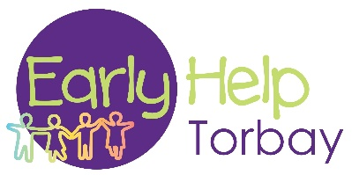
Early Help general enquiries: earlyhelp@torbay.gov.uk

Multi-Agency Safeguarding Hub (MASH):
01803 208100 or Torbay.Safeguarding@torbay.gov.uk

