

**Independent Remuneration Panel Members**

**Applicant Information Pack**

Torbay Council

Town Hall

Castle Circus

Torquay

TQ1 3DR

[governance.support@torbay.gov.uk](mailto:governance.support@torbay.gov.uk)

[www.torbay.gov.uk](http://www.torbay.gov.uk)

|  |
| --- |
| **Contents** |

**Section**

1. About our Council

2. About the Independent Remuneration Panel

3. Description of the Role

4. Personal qualities required

5. Application process

6. Current Members’ Allowances Scheme

|  |  |
| --- | --- |
| **1.** | **About our Council** |

|  |
| --- |
| **Our Location** |
| Torbay is situated in the south of Devon and is made up of the three coastal towns Brixham, Paignton and Torquay. Torbay is also known as the English Riviera.  Torbay covers an area of just under 64 Square Kilometers (25 square miles) and has approximately 45 Kilometers (27 miles) of coast line with 20 public beaches.  Torbay Council is a unitary authority and is responsible for all Council services within Torbay. |

|  |
| --- |
| **Our Democratic Structure** |
| The Council currently comprises 36 Councillors covering 16 wards. They are responsible for making decisions on behalf of the local community about services provided by the Council. Its current political composition is:  Conservative 18  Liberal Democrat 15  Independent Group 3  The Council operates under a Leader and Cabinet model of Governance since May 2019. The Cabinet is at the heart of the day-to-day decision making process and have a key role in proposing budget and policy framework to the Council, taking into account the views of the Overview and Scrutiny Board or any of its other Committees, with a view to delivering the key principles of supporting thriving people, a thriving economy, tackling climate change and providing a Council that is fit for the future. |

**Decision Making Structure**

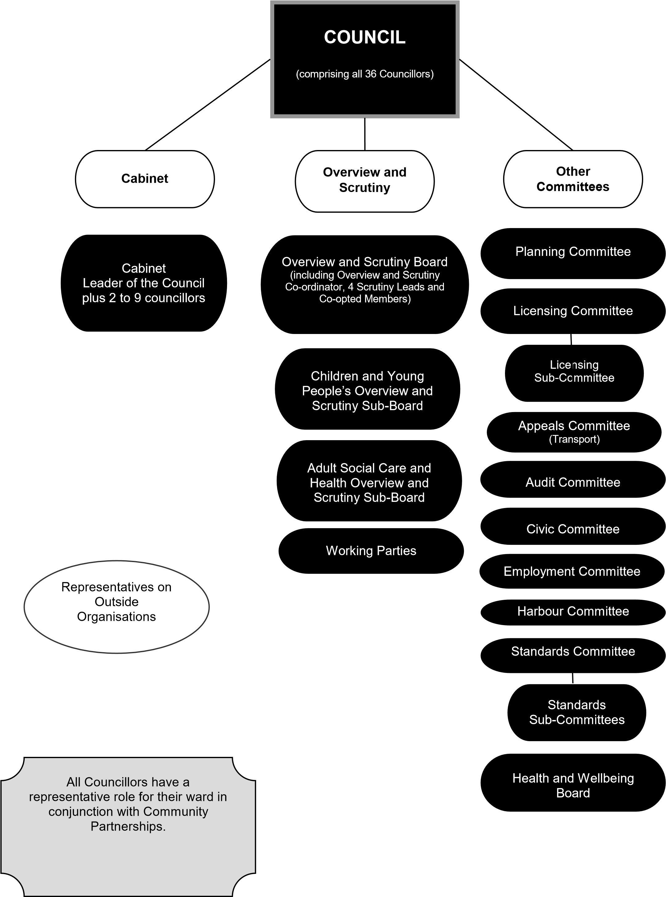

|  |  |
| --- | --- |
| **2.** | **About the Independent Remuneration Panel** |

|  |
| --- |
| All Councillors (known as ‘members’) receive a basic allowance which helps to cover the cost of being a member (e.g. telephone, stationery, costs of visiting constituents etc.). The Leader and some Councillors who have additional responsibilities also receive a Special Responsibility Allowance. Details of all allowances payable to members are set out in the Council’s Members Allowances Scheme which can be found under Part 6 of the Council’s Constitution.  The Council is required (under the Local Authorities (Members’ Allowances) Regulations 2003) to establish and maintain an Independent Remuneration Panel to keep the Members’ Allowances Scheme under review and make recommendations to the Council regarding the Scheme. Independent Remuneration Panels make recommendations about the levels of: basic allowance for all members; the special responsibility allowances which can be paid; childcare and dependent carers’ allowances; and travel and subsistence allowances payable and how the allowances are uprated each year.  The Panel is required to consist of at least three members.  Members of the Independent Remuneration Panel must not be an elected member of the Authority or a member of any committees of the Authority and must not be disqualified from becoming a member of the Authority, i.e. must not be:   * an employee of Torbay Council or Brixham Town Council; * an adjudged bankrupt; or * have been sentenced to imprisonment for three months or more within the last five years; or * disqualified for being a member of the relevant council under Part III of the Representation of the People Act 1983 or for being a charter trustee under the Audit Commission Act 1998; or * a disqualified person for the purposes of s81A of the Local Government Act 1972 and subject to notification requirements or a relevant order under Part 2 of the Sexual Offences Act 2003.   A full review of the Members’ Allowances Scheme takes place at least once every four years. The Panel will be undertaking a full review during 2027. It is expected that the Panel will meet virtually three to four times to undertake the full review. The Panel may meet virtually once or twice a year between reviews or may be consulted via email on minor changes to the Scheme.  The post is on a voluntary basis for a four year term of office although reasonable expenses will be considered. |

|  |  |
| --- | --- |
| **3.** | **Description of the Role** |

|  |
| --- |
| **Main duties and responsibilities**  To work with the Senior Democratic, Overview and Scrutiny Officer to keep under review Torbay Council’s Members’ Allowances Scheme and receive evidence and make recommendations to the Council on any proposed changes to that Scheme.  The Independent Remuneration Panel has the following functions:   * To make recommendations to the Council on the amount of basic allowance which should be payable to its elected members. * To make recommendations to the Council about the roles and responsibilities for which a special responsibility allowance should be payable and as to the amount of each such allowance. * To make recommendations as to whether the Council’s allowances scheme should include an allowance in respect of expenses for the care of children and dependents, the amount of this allowance and the means by which it is determined. * To make recommendations as to which Members of an authority are to be entitled to pensions in accordance with a scheme made under section 7 of the Superannuation Act 1972. * To make recommendations as to treating a basic allowance or special responsibility allowance, or both, as amounts in respect of which such pensions are payable in accordance with a scheme made under section 7 of the Superannuation Act 1972. * To make recommendations on co-optees, travel and subsistence allowances. * To make recommendations as to whether, in the event that the scheme is amended at any time so as to affect an allowance payable for the year in which the amendment is made, payment of allowances may be backdated. * To make recommendations as to whether adjustments to the level of allowances may be determined according to an index and if so which index and how long that index should apply, subject to a maximum of four years, before its application is reviewed.   The Council will provide the Panel with information about the roles of councillors and the way in which the Council operates.  The Panel will have regard to this information and in addition may seek to undertake its own research on the role of councillors and the work of other independent remuneration panels.  A copy of the current Members’ Allowances Scheme is enclosed with this pack.  The Independent Remuneration Panel established by Torbay Council may also act as the Independent Remuneration Panel for any Parish and Town Councils within Torbay.  **Note:** Legal advice will be provided by South West Councils and administrative support is available from officers of the Council. |

|  |  |  |  |  |
| --- | --- | --- | --- | --- |
| **4.** | | **Personal qualities required** | | |
| **Personal Attributes** | | | | |
|  |  | | Essential | Desirable |
| 1. | Personal integrity | | √ |  |
| 2. | Ability to make informed judgements based upon complex information | | √ |  |
| 3. | Commitment to upholding high standards | | √ |  |
| 4. | Commitment to confidentiality in accordance with the Council’s wishes | | √ |  |
| 5. | Ability to attend and contribute to Panel meetings | | √ |  |
| 6. | No affiliation to any political group or party | | √ |  |
| 7. | Knowledge of how Local Government works | |  | √ |
| 8. | Knowledge of rules of natural justice | |  | √ |
| 9. | Experience of committee work | |  | √ |
| 10. | Experience of setting remuneration levels for other companies or local authorities | |  | √ |
| **Disqualification** | | | | |
| Persons will be disqualified from serving on the Panel if they: | | | | |
| 1. | Are an elected Councillor/Mayor of any local authority. | | | |
| 2. | Are employed or appointed by Torbay Council or any Parish or Town Council within Torbay. | | | |
| 3. | Are a senior employee (in a politically restricted post) of another local authority. | | | |
| 4. | Are the holder of any position within a political party at local, regional or national level. | | | |
| 5. | Are the subject of a bankruptcy restrictions order or interim order. | | | |
| 6. | Have been convicted in the last five years of an offence with a sentence of imprisonment (whether suspended or not) for a period of not less than three months without the option of a fine. | | | |
| 7. | Are in debt to or in dispute with Torbay Council or any Parish or Town Council within Torbay. | | | |
| 8. | Are a relative or personal friend of an elected member of Torbay Council or any Parish or Town Council within Torbay. | | | |
| 9. | Are disqualified for being a member of the relevant council under Part III of the Representation of the People Act 1983 or for being a charter trustee under the Audit Commission Act 1998. | | | |
| 10. | Are subject to the notification requirement of or under Part 2 of the Sexual Offences Act 2003, and the ordinary period allowed for making an appeal or application in respect of the order or notification has passed12. A disqualification set under s.81A of the Local Government Act 1972 will only apply to a person who is subject to any relevant notification requirements or relevant order made on or after 28 June 2022. | | | |

|  |  |
| --- | --- |
| **Removal from the Panel** | |
| The Council will have the right to remove particular members from the Panel before their four year term expires in special circumstances such as: | |
| 1. | Becoming disqualified for any of the reasons identified in the ‘Disqualification’ section above. |
| 2. | Persistent non-attendance at meetings. |
| 3. | Breach of confidentiality. |
| 4. | Conduct that brings the Panel into disrepute and/or prejudices its impartiality or its effective operation. |

|  |  |
| --- | --- |
| **5.** | **Application process** |

|  |
| --- |
| **Response Instructions** |
| Please complete the application form enclosed and submit you application together with any other supporting information **by 5 pm on the 14 February 2025** to:  Teresa Buckley  Democratic Services Team Leader, Town Hall, Castle Circus  Torquay  TQ1 3DR  Email: [teresa.buckley@torbay.gov.uk](mailto:teresa.buckley@torbay.gov.uk) |

|  |
| --- |
| **Additional Information for Applicants** |
| **Expenses**  The post is on a voluntary basis for a four year term of office although reasonable expenses will be considered.  **Availability**  It is expected that the Panel will meet virtually (on Teams) three or four times to undertake the full review in 2027. The Panel may meet virtually once or twice a year between reviews or may be consulted via email on minor changes to the Scheme. Communication is undertaken by email whenever possible. All meetings are held in the daytime.  **References**  Please provide the name and addresses of all employment references covering the last three years, including your present or most recent employer if applicable.  **Selection**  Short listing for these appointments will be based upon an assessment of how applicants meet those criteria listed in the ‘Personal Qualities Required’ section of the application form. When completing the additional information section of the form, please show how you meet the criteria. Appointments will be made by the Chief Executive upon the recommendation of a selection Panel.  **Progress of Application**  If you have heard nothing concerning your application within 28 days of submission of your application, then you should assume that your application has been unsuccessful. |

|  |  |
| --- | --- |
| **6.** | **Current Members’ Allowances Scheme** |

Torbay Council has made the following scheme for the payment of allowances to members from 1 April 2024, in accordance with the Local Authorities (Members' Allowances) Regulations 2003.

1. In this scheme:

“councillor” means an elected member of Torbay Council;

“co-opted member” means the following:

(a) Statutory co-optees (diocesan authority and parent governor representatives).

**Basic Allowance**

2. Subject to paragraph 10, an annual Basic Allowance (BA) will be paid to each councillor. For the year commencing 1 April 2024 the Basic Allowance is **£10,273**. This is intended to recognise the time commitment of councillors on constituency duties and attending meetings and travel on non-approved duties etc; dealing with correspondence; and costs relating to the use of the councillors’ home such as telephone charges, broadband, stationery, postage and office equipment.

**Special Responsibility Allowances**

3. (a) Subject to paragraph 10, an annual Special Responsibility Allowance (SRA), will be paid in addition to the Basic Allowance to those councillors who hold the special responsibilities listed below. The SRA is paid to recognise the additional commitment and time required to fulfil each role and covers subsistence and travel for attending meetings not listed in Schedule 1.

**Leader of the Council** £25,684

**Deputy Leader of the Council** £15,410

**Cabinet Members:**

* Collective decision making £13,356

**Overview and Scrutiny Co-ordinator** £8,219

**Scrutiny Lead Members who Chair Adult Social Care**

**and Health Overview and Scrutiny Sub-Board and**

**Children and Young People’s Overview and Scrutiny Sub-Board** £6,164

Scrutiny Lead Members who Chair ad hoc Task and Finish Groups £4,109

Chairman/woman of **Planning Committee** £8,219

Chairman/woman of **Statutory Licensing Committee** £4,109

Chairmen/women of **Statutory Licensing Sub-Committees** (excluding

Chair of Licensing Committee)**:**

* 10+ meetings £1,335
* 5-9 meetings £719

Chairman/woman of **Regulatory Committee** £4,109

Chairmen/women of **Regulatory Sub-Committees** (excluding

Chair of Licensing Committee)**:**

* 10+ meetings £1,335
* 5-9 meetings £719

Civic Mayor£4,109

Chairman/woman of **Harbour Committee** £4,109

Chairman/woman of **Audit Committee** £4,109

Chairman/woman of **Health and Wellbeing Board** £4,109

**Leaders of Political Groups:** (an allowance per member

excluding the Group Leader) £411

(b) No councillor will be entitled to receive more than one Special Responsibility Allowance.

**Co-optees’ Allowance**

4. Subject to paragraph 10, an annual co-optees’ allowance of £145 shall be paid to each co-opted member (to include expenses for travel and subsistence).

**Independent Person for Audit Committee Allowance**

5. An allowance of up to £1,035 per annum shall be offered as renumeration to the Independent Person for the Audit Committee.

**Civic Allowances**

6. The Council has chosen to pay a Civic Allowance for each Municipal Year (which is outside of the Members’ Allowances Scheme) to the Chairman/woman of the Council to assist them in carrying out their civic and ceremonial role. This is in addition to the SRA received by the Chairman/woman of the Council.

Individual’s Acceptance of Allowances

7. A councillor or a co-opted member may choose to not accept all or part of his or her entitlement to an allowance under this scheme by giving written notice to the Head of Governance Support.

**Part-year Entitlements**

8. Councillors and co-opted members will be paid for the period they serve and if this is less than a whole year payments will be made on a pro-rota basis on the number of days applicable. This also applies to those holding positions of special responsibility and if the Scheme is amended during the year.

9. In the year of a local election the Chairman/woman of the Council and Vice-Chairman/woman of the Council will continue to receive their SRA and Civic Allowances up to the day of the Annual Council meeting. This includes where they are not re-elected.

**Tax and National Insurance Contributions**

10. The Basic Allowance and any Special Responsibility Allowances are subject to Tax and National Insurance contributions by the PAYE process operated by the Council and these allowances will be paid automatically to councillors in twelve monthly instalments. Co-optees Allowances are also subject to Tax and National Insurance contributions and are paid in a single payment at the end of each financial year.

**Suspension**

11. Where a councillor is suspended or partially suspended their Basic and/or Special Responsibility Allowance and any other allowances they would normally be entitled to will be stopped for the period of the suspension.

**Travelling and Subsistence Allowances**

12. Councillors and co-opted members may claim Travelling and Subsistence Allowances for approved duties listed in Schedule 1 at the rates set out in Schedule 2. These are not subject to tax. Prior written approval should be obtained from the Head of Governance Support for travel abroad or first class travel.

**Childcare and Dependent Carers’ Allowance**

13. (a) An Allowance equal to the cost incurred may be claimed when a carer has been engaged to enable a councillor (including those members in receipt of an SRA where that member is representing the Council at a formal external meeting in that capacity, including any acting as an approved substitute as notified by the relevant Group Leader to the Head of Governance Support in advance of the meeting) or a co-opted member to carry out an approved duty listed in Schedule 1.

(b) The Allowance will cover paid care for the following who live with the claimant:-

- children aged 15 years and under;

- elderly relative requiring constant care;

- disabled relative requiring constant care; or

- relative with learning disabilities requiring constant care.

(c) The paid carer cannot be a member of the immediate family or household.

(d) As per HMRC regulations, no tax relief is due for the cost of a carer and any claim will be subject to tax.

**Duties which fall outside the Scheme**

14. The Head of Governance Support is authorised to approve Travel and Subsistence and Childcare and Dependent Carer’s Allowances for duties that technically fall outside the scheme (provided, that in the case of childcare and dependent carer’s allowances, they meet the requirements of 13 above) where he/she is satisfied that the expenses incurred are essential to the proper conduct of Council-related business.

**Up-rating of Allowances**

15. The Basic Allowance, Special Responsibility Allowances and Co-optees Allowances will be indexed, on the 1 April each year from 2024, to the percentage of the average of the staff pay increase (to be calculated annually by the Director of Finance) following the annual local government pay percentage increase as agreed by the National Joint Committee for Local Government Services.

The Travel and Subsistence Allowances will be up-rated as and when the officers’ scheme is adjusted, subject to the requirement in the Regulations for this index to apply for no longer than four years without a further review of the Allowances Scheme by an Independent Remuneration Panel.

**Claims and Payments**

16. A claim for a Travel and Subsistence Allowance and a Childcare and Dependent Carers’ Allowance under this scheme must be made in writing or the Council’s MyView system within **three months** of the date of the meeting and must be supported by appropriate receipts.

17. Claims must be submitted to the Governance Support Team by 1st of the month (or the next working day if the 1st falls on a weekend or bank holiday). Payments will be made on 25th of each month by BACS.

18. All questions about the interpretation and application of any of the allowances should be emailed to the Chief Executive.

**Parking Permit**

19. Members have the option to purchase either an annual car parking permit at £100 to include all Council owned car parks or to pay to park on an ad-hoc basis in line with the charges applicable to staff.

**Schedule 1**

The following duties are recognised as approved duties for the payment of Travel and Subsistence Allowances and Childcare and Dependent Carers’ Allowances:

i) attendance at meetings as a duly appointed member of:

(a) the Council and any committee of the Council;

(b) any sub-committee appointed by a committee;

(c) the Cabinet or committee of the Cabinet (if appointed);

(d) working parties (including the Member Development Group and Leadership Group);

(e) scrutiny review panels;

(f) policy development groups;

(g) any outside organisation and their sub-groups appointed by the Council or the Cabinet, provided that the organisation does not pay any such expenses (these are listed on each Councillor’s details page on the Council’s website at [www.torbay.gov.uk/DemocraticServices/mgMemberIndex](http://www.torbay.gov.uk/DemocraticServices/mgMemberIndex.aspx?bcr=1));

(ii) Members in receipt of an SRA where that member is representing the Council at a formal external meeting in that capacity, including any acting as an approved substitute as notified by the relevant Group Leader to the Head of Governance Support in advance of the meeting

(iii) attendance at internal Cabinet/Senior Officer meetings (Cabinet and Directors’ meeting (CAD));

(iv) attendance at internal cross party governance meetings with Councillors and Senior Officers, for example, Council Leadership Group;

(v) attendance at LGA Boards (for Torbay Councillors) who are members of those Boards but not appointed by Torbay Council;

(vi) attendance at site visits for planning or licensing purposes or as part of overview and scrutiny by committee/board members;

(vii) attendance at member development sessions;

(viii) attendance at seminars and all member briefings organised by Torbay Council, except for those held immediately prior to a meeting of Council;

(ix) attendance at non-political conferences/seminars, subject to prior approval by the relevant Group Leader and Head of Governance Support and funding for the conference being available (in accordance with the Local Protocol for the Leader of the Council and Political Groups); and

(x) members who are not the appointed member of the bodies listed below are able to claim mileage and carers’ allowance (excluding subsistence allowance) for attendance in person at meetings of the following (with effect from 1 January 2024):

1. the Council and any committee of the Council;
2. any sub-committee appointed by a committee;
3. the Cabinet or committee of the Cabinet (if appointed);
4. working parties; and
5. scrutiny review panels.

**Schedule 2**

**Travelling and Subsistence Allowances**

The following travelling allowance may be claimed with effect from June 2023 (the date the rates came into force) and rates for travel will be the same as those set out in the Torbay Council Expenses Policyfor those duties listed in Schedule 1:

**Travelling Allowances**

(a) Motor Cars – 45p per mile

(b) Electric Car – 40p per mile

(c) Motor Cycles - 40p per mile

(c) Bicycles - 40p per mile

(d) Taxi - councillors and co-opted members may claim taxi fares provided that the journey is necessary to undertake an approved duty of the Council and where no public transport is reasonably available.

A member may claim a maximum of 40 miles for a round trip for attending approved duties within Torbay. However, where a member is temporarily residing outside of Torbay and is required to attend an approved duty in Torbay they will be able to claim the travel allowance from their temporary residence on a one-off ad hoc basis with the prior agreement of the Head of Governance Support (such travel should be by the most cost effective means).

**Notes:** For all journeys, councillors and co-opted members will be expected to use the most appropriate means of transport possible. This includes public transport. For travel outside Torbay, councillors and co-opted members should agree in advance with the Head of Governance Support whether travel by car, train or other public transport is appropriate before any journey is undertaken.

All claims for travel on public transport must be accompanied by a receipt.

All claims for travel by car or motor cycle must be accompanied by a VAT fuel receipt which must be for at least one-third of the total amount of the claim. One receipt may be used for more than one journey provided it covers at least one-third of the total amount claimed. This is to enable the Council to reclaim the VAT on the fuel element of the mileage claims.

##### Subsistence

The following subsistence allowances may be claimed with effect from June 2023 for those duties listed in Schedule 1:

(i) **Breakfast** allowance (departure from home before 8.00 a.m.) **£7.06**

(ii) **Lunch** allowance (absent from normal place of work during

12.00 noon and 2.00 p.m.) **£9.72**

(iii) **Evening** meal allowance (not home before 6.00 p.m.) **£13.44**

**Notes:** Subsistence rates for councillors and co-opted members are calculated on a meals basis dependent on the time of day the meal would be taken and the time away from home. All claims for subsistence must be accompanied by a receipt. The maximum allowance will only be paid where the cost of the subsistence is equal to, or greater than, the maximum amount.

Where subsistence is provided by the Council or event organiser, subsistence claims will not be paid, even where a member declines to accept the subsistence provided and makes their own provision.

**Other expenses**

The actual amount incurred on any tolls, ferries or parking fees shall be reimbursed. All claims for such expenses must be accompanied by a receipt.

In the case of an absence overnight from their usual place of residence, councillors and co-opted members may be entitled to claim reasonable expenses by agreement in advance with the Head of Governance Support.

Note: Schedule 2 has been updated with effect from June 2023 to reflect the change in rates for staff.