**Site Location Plans**

These plans enable the Local Planning Authority to identify the land to which the application refers to and should be based on an up-to-date map. This guide outlines the site location plan that you must submit with your application.

Site location plans can be obtained online (search for eg “site location plan creator”).

**Site location plans:**

-The application site should be edged clearly with a red line

-It should be at an identified standard metric scale (typically 1:1250 or 1:2500 for larger sites)

-it should have a North marker.

-It should be scaled to fit on an A4 size document.

-It should show sufficient roads and/or buildings on land adjoining the application site

-It should show application site boundaries and all land necessary to carry out the proposed development i.e. land required for access to the site from the road, outlined in red.

-A blue line should be drawn around any other land owned by the applicant that is close to or adjacent to the property.

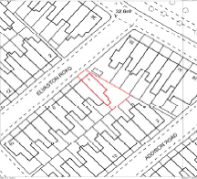

The road the property is located on and the neighbouring properties should be clearly visible

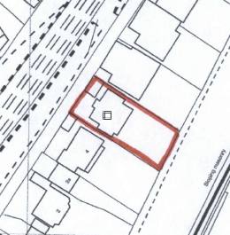

The red line should be taken around the whole property i.e. including the garden (Unless the application is for flat-see below)

(Please note that these images are not to scale)

Where the application is made for a **flat** the flat itself should be indicated by the red line and not the whole building (see example plan below)

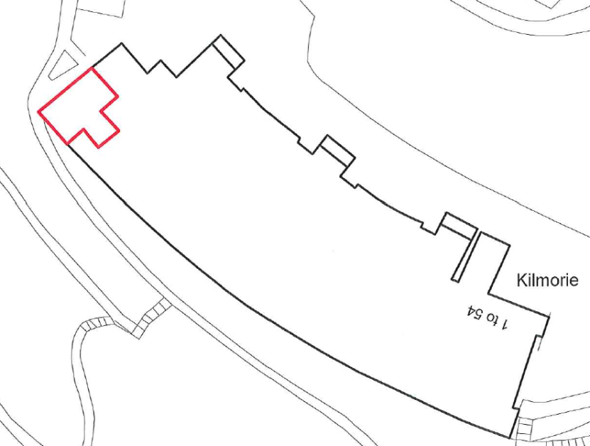

Only the flat to which the application relates should be marked with a red line

**What we can validate and what we cannot validate:**

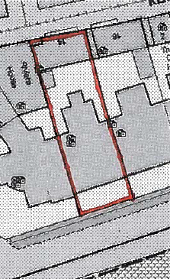  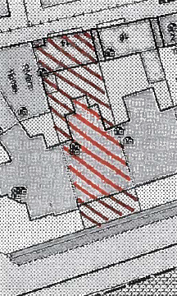

As single and continuous red line

No cross hatching

The colour must be red

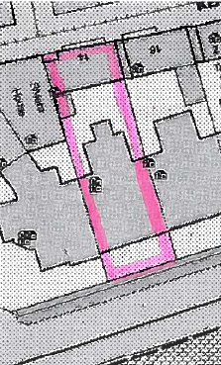  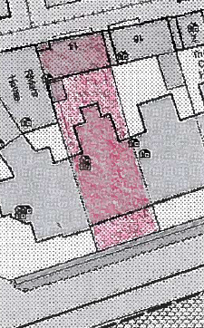

No block filling

Please note the images included are examples and are only images of the plan and don’t include the north arrow, licence number or copyright statement which will feature on the A4 plan. The site plan can also be displayed in colour.

**Older Land Registry plans -** Please note older Land Registry Plans were often produced at an imperial page size “foolscap”. It is important that such plans are not reduced in size to A4. Reducing the size of the page renders the scale inaccurate. The plan will then be invalid.

When using **Ordnance Survey** mapping for planning applications, the map should:

-Not be used for multiple applications.

-Show OS Crown copyright as an acknowledgment.

-Not be a photocopy or screen grab image.

-Not to be copied from existing OS mapping if using hand drawn maps – such as standard sheets.

-Show the correct licence number if you wish to print or copy maps for applications.

**If you require any further information or clarification on Ordnance Survey Licences and Copyright, please contact the Ordnance Survey Helpdesk on 03456 050505.**