Short survey for children and young people – Proposed improvements to education services for children with additional needs
Torbay Council wants to know what you think about our plans to make education services for children and young people with additional needs better.
- Your age
- Your postcode
Tell us what you think about each of our plans:
3. Locality model – This is a plan to group schools into local ‘Clusters’ to help young people who need extra support do better. A Cluster is a group of schools in the same area that work together to help children and young people. Think of it like a team where each school is a player. They share ideas and resources to make sure every child and young person gets the support they need. Each Cluster will include your school, local doctors and nurses, parents, and other community helpers. This plan is for children and young people aged 5-18 and will start in September 2025. Changes will happen slowly, not all at once. Special schools are not part of this plan.  What do you think about this idea? Do you: | 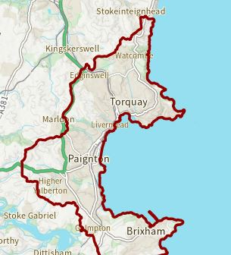
Strongly agree
Agree
Neither agree nor disagree
Disagree
Strongly disagree

- Getting help more quickly - This plan means young people won’t need a diagnosis or an Education Health and Care Plan (EHCP) to get help. The clusters (like we talked about before) will improve the support they already have for all young people, so you can get help quickly without having to wait.  What do you think about this idea? Do you: | 
Strongly agree
Agree
Neither agree nor disagree
Disagree
Strongly disagree

- Getting the right people round the table - Each cluster will have a group of people from schools and other local helpers who decide what kind of help is needed and how to give it. This help could be special activities for young people, a place (hub) where you can go to get help, or experts from other schools coming to help young people in the cluster.  What do you think about this idea? Do you: | 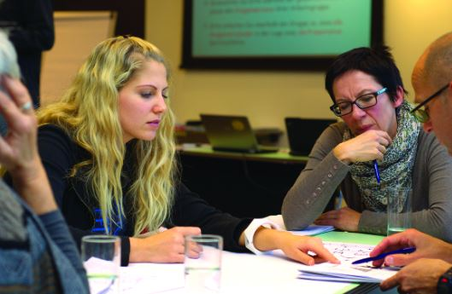
Strongly agree
Agree
Neither agree nor disagree
Disagree
Strongly disagree

- More support, more flexibility - One of the ideas is to create new Enhanced Resource Bases (ERPs or Hubs) for each Cluster. An ERP is a special place in regular schools to help young people who find it hard to stay in a regular classroom all day and might need to learn in smaller groups. This plan will keep the idea of these ERPs but make them more flexible to help more young people, even if they don’t have an EHCP.  In our plan, these ERPs or Hubs will:  - Offer more Outreach Services to other schools in the Cluster,  - Provide short-term and flexible support to young people (instead of a long-term spot in the hub), and  - Be open to young people with and without an EHCP or diagnoses.  What do you think about this idea? Do you: | 
Strongly agree
Agree
Neither agree nor disagree
Disagree
Strongly disagree

- Making Better use of Parkfield – As part of the plans we are looking at making better use of Parkfield as a ‘multi-use’ hub. The plan is for it to be used by Mayfield sixth form students between 9am and 3pm in term time, but used by community groups to provide support for Torbay’s young people in the afternoons, evenings and weekends.  What do you think about this idea? Do you: | 
Strongly agree
Agree
Neither agree nor disagree
Disagree
Strongly disagree

- Do you have any other comments about these plans?
Thank you for your time

You can email your response to Localityconsultation@torbay.gov.uk

