Torbay Learning Disability Partnership Board

August 2024

**People at the meeting**

Neil, Sharon, Mike, Lorraine, Nigel, Anna, Suzanne, Alison, Tracie, Mark, Debbie, Hayley, Corenna, Kevin, Helen, Jo, Alison, Lindsey, Alan, Pam, Charlotte.

**Introductions and Apologies.**

Everyone introduced themselves.

Apologies from Kate Marks, Jo Williams, Lee Baxter, Cathy Williams, Savana Guy, Adam Russell, Carol Grey, Beverley.

**Minutes of the last meeting**.

The minutes were read and everyone agreed they were ok.

Neil thanked everyone for wishing him a happy birthday.

Action 1. Sharon and Savana to talk to Gabriella about the Sharon said that there has been one meeting and another meeting is planned.

Action 2. Savana to invite Alan Denby to the next meeting to talk about transport.

Alan is at the meeting.

**Transport questions for Alan**

Everyone welcomed Alan to the meeting.

Alan had been sent questions before the meeting.

1. Can bus passes start before 9.30am so that people can go to work?

Alan said that the times are set by the Government. It could be very expensive to change this. Alan said that Hayley could talk about this with the Council.

Action – Jo to speak to Hayley about changing the policy

Action – Alan will look at how much it could cost and tell Hayley.

1. Are there any plans for talking bus stops?

Alan said it would cost a lot of money to change all the bus stops. Alison asked if other areas use talking bus stops, but Alan did not know any.

1. A couple of elderly women standing next to a red bus

   Description automatically generatedAre there any plans for free Family Carer Cards so that Alan said there are no plans but the Council is introducing the ‘My Bay’ card which helps with parking.
2. A white board with a clock and a bus

   Description automatically generatedCan bus timetables be made more accessible?

Alan said there are no plans to change them but it would help if the Ambassadors can give some examples of what would be better.

1. A screen shot of a parking lot

   Description automatically generatedCar parks often charge a minimum of 4 hour parking or all day. Can parking be more flexible?

Alan said there will be a consultation soon about parking so people can give feedback.

1. 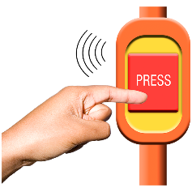Are there any plans for talking buses which tell people the next stop?

Alan said they are talking to Stagecoach about this.

Some bus drivers don’t wait for people to sit down and this is dangerous. The Buses are often very full and it is hard for people to get off at the right place. Alan said he will talk to Stagecoach about this.

1. Are there any plans for more electric charging points which can charge quickly?

Alan said that in the next year, the number of charging points will go up. Alan is happy to have feedback about this.

Everyone thanked Alan for coming to the meeting.

**Ambassadors Report**

The Ambassadors read their report.

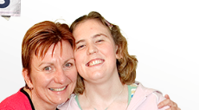**Carers Update**

The Carers talked about their report.

* Kevin and Pam held an ‘Meet the Carers’ session. They are going to do another session on Carers Rights Day in November.
* The Carer reps have a new email address

[ldpbcarerreps@torbay.gov.uk](mailto:ldpbcarerreps@torbay.gov.uk)

* 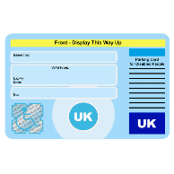Carers are not sure about the criteria for getting a Blue Badge because some people with higher levels of mobility for PIP are not being given a badge.
* 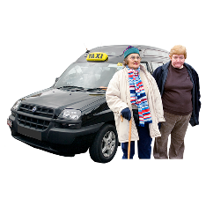Carers would like an update about the taxi consultation. Hayley said there had not been enough feedback so it is being done again and Carers can say what they think.
* The Torbay Family Carers groups have met with Deborah Gidman, Sharon and Zoe Dunn to talk about issues with Adult social care.

Sharon said that it had been recognised how hard it is for Carers and their voice has been heard.

* 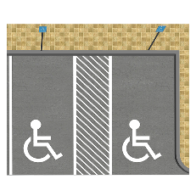Kevin talked about the new barriers at the disabled parking area at the hospital because there seems to be problems for people trying to leave. Sharon said she will talk to the estates team.

**Treat Me Well feedback**

Sharon and the Ambassadors enjoyed the Hospital walkabout day.

Sharon said that some improvements had been

identified and an action plan has been made.

The Autism Ambassadors would like to do a walkabout day so they can give their feedback.

Sharon said that missed appointments need to be looked at as patients with a learning disability who miss an appointment are marked as ‘did not attend’ but they may have a good reason and need more support.

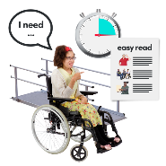Alison talked about how important it is for patients to have the right information when people leave hospital. Alison also talked about reasonable adjustments and having headphones and cat toys which people can stroke to help them.

Alison asked for any other ideas about how to make things easier for people in hospital.

**Langdon Update**

Carol could not come to the meeting. Neil talked about the history of Langdon and some of the lived experiences of people in the community. The presentation and information had not helped people feel that the hospital was a good thing.

**Any other business**

* Kevin said he had heard that direct payments are going to change. Sharon said they are not changing but they are working to make information more accessible.
* Jo Williams is retiring in March 2025.
* Carers Rights Day is on 23rd November and is at Paignton Library.

Neil and Sharon thanked everyone for coming.