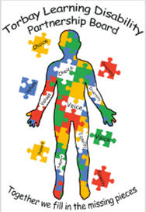**Minutes of Torbay Learning Disability Partnership Board**

12th January 2023

**People at the meeting**

Neil, Tracie, Lorraine, Mike (Ambassadors), Adam, Jude, Cathy, Correnna, Helen Burns, Helen Dunlop, Lindsey, Councillor Stockman, Si.

**Apologies**

Sharon O’Reilly, Jo Williams, Shaun and Jamie (Ambassadors) Alex, Leanne, Pam.

**Introductions**

Neil welcomed everyone to the meeting.

Everyone introduced themselves.

**Minutes of the last meeting**

Neil asked everyone if they agreed with the minutes of the last meeting. The action points were read.

Adam said there were delays with the Finance and Benefits Assessments and work is being done to catch up.

The work the Ambassadors have done about the Toilet cards should be written about so it can be shared.

The feedback from the Housing event was very good and providers want to be more involved at the next event.

Adam said that Mark Richards from Public Health may be able to help with worries about Dental services. Sarah from Healthwatch gave an update in the meeting.

There has been no feedback from the Job Centre after the last meeting.

Adam said that Jo Williams wants to be involved with the Partnership Board and perhaps the Board would be able to think about making changes to times and days to make sure Jo can attend.

Lyndsey said the advert for a new carers rep has been sent out in the newsletter.

Jon and Sharon will bring information about the new Norfolk Ruling to the next meeting.

**Ambassadors Report**

The Ambassadors read their report.

Adam said the video about the LeDer report was sobering. He asked what information needs to be shared to help make things better?

The Ambassadors said they thought more communication and work with doctors is important and that training is needed too for all staff.

Everyone at the meeting talked about the need to think about diet, food and cooking, and how important it is for everyone to be involved in making people’s health better.

Adam recommended that Adult Safeguarding Board should know about the LeDer report feedback as everyone is there to listen.

The Ambassadors talked about their visit from Francesca at United Response. Francesca reported that she has talked to people about day activities and people want more information and more choice.

Adam said that day services are going to be looked at and everyone needs to be included in the discussion. A lot of money is being spent on day services and it is important to make sure it is used in the right way.

Si said young people needed to be included too.

We talked about tourism in Torbay and the difficulties for people with disabilities wanting to come to the area. There is a lot of work which needs to be done and a separate group may be needed so they can concentrate on tourism.

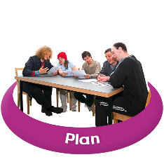**Strategy**

Jude explained that she is writing a new strategy. She has read all the information which people had said in the past. Jude explained that the strategy will be short and will focus on what people have said. There will be only one accessible version for everyone.

The strategy will be a masterplan and any action plans will need to match the strategy.

The strategy needs to include everyone including people with complex needs.

Jude would like to meet with the Ambassadors to talk about the strategy.

**Healthwatch**

Sarah gave an update about dentists which the Ambassadors raised at the last meeting.

Healthwatch contacted NHS England and talked about accessible information for people. NHS England have accessible letters and have put them on a database so that services can use them.

Healthwatch and the Ambassadors are going to try and find out if the information is being sent out.

Healthwatch Torbay are interested to know about people’s experience waiting for a social care assessment.

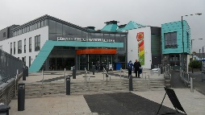There is a new community hub at Paignton where people can get help face to face. There are some health specialists at the Hub, including Diabetic eye screening. The Hub is open on Tuesday, Wednesday and Thursday from 9.30 – 12.30 in Paignton library.

**Torbay Family Carers**

Helen said they had really enjoyed the Housing event. There were a lot of enquiries from carers who want to plan for the future.

Adam said it is important to provide help and support about future housing. In the past, there were specialist teams and people with learning disabilities need longer term relationships with professionals.

Helen talked about the need for consistency and the difference that it makes when professionals get to know people and their situation. Everyone needs to be included in conversations.

Adam asked for an agenda item so that we can talk about the specialist services because a lot of health services are managed by Devon Partnership Trust so can be hard to access.

Correna reported that Hollacombe have very good relationships with health professionals who visit their clients. Consistency is very important, including in care management.

**Any other business**

Lyndsey reported that the advert for the Carers Rep was out and she asked if the Ambassadors would be able to help with the interviews. Neil agreed that they would.

Cathy Williams thanked everyone at the meeting for the warm welcome. Cathy is looking at what is good and what needs improving in social care so that Torbay is ready for CQC Inspection.

Neil thanked Adam for standing in as Co-Chair.

Sharon will be back for the next meeting.

The next meeting is booked for 6th April. Venue to be arranged.