SITE OVERVIEW: Yellow site – minor constraints
Town | Torquay
Site Name | TNPH26 Municipal Chambers, Union Street
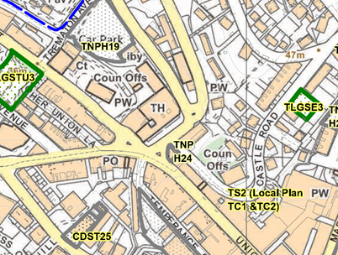
Allocation or HELAA Reference no. | 21T035  Houisng proposal TNPH26  NP ref – TNPH24  T795
Approx. yield | 12 dwellings
Suitable: How the principle of development is established | Yes - Allocated site
Available: Any change in circumstances since principle established | Ground floor units in use as A1/A2 (E)  P/2006/1236 | Conversion Of Upper Floors To Form 12 One Bedroom Flats - approved
Achievable | Achievable subject to availability.
Customer Reference no. | Leave Blank for now
Current use | Vacant building with ground floor units in use as A1/A2 (E)
Site description | Building located to the south of Torquay Town Hall fronting onto Union Street
Total site area (ha) | 0.02

AVAILABILITY ASSESSMENT
Reasonable prospect of delivery (timescale):

Confirmation of availability needed from owners.
The next 5 years
A 6-10 year period | 12
An 11-15 year period
Later than 15 years

