SITE OVERVIEW: Red rejected site
Town | Torquay
Site Name | Ansteys Playing Field Car Park
HELAA Reference no. | 21T079  T773 (Rejected)
Approx. yield | Up to 6.
Suitable | No . Loss of car park serving plying field. Encroachment onto LGS, isolated area, poor access. Coastal Change Management Area.
Available | Subject to a review of car parks
Achievable
Customer Reference no. | Leave Blank for now
Source of Site (call for sites, Local Plan allocation etc.). | Council Car Park/ULPA
Current use | Car Park
Site descriptions | Car park on north of Stoodley Knowle Playing field. The car park is not LGS, but the playing field is a LGS.
Total site area (ha) | 0.24ha
Gross site area (ha)
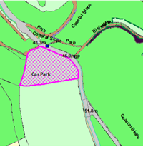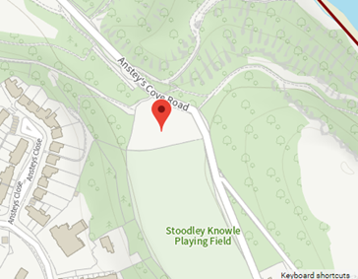
SUITABILITY ASSESSMENT: STAGE A

Strategic potential: | No
Housing? | Unlikely
Employment? | No
Other Use? | No
Biodiversity- Within SAC/SSSI | Within 250m of SSSI but little onsite biodiversity as the site is a car park.
Flood Zone 3b | No
Other NPPF Showstoppers (not policy constraints) | No
Conclusion

SUITABILITY ASSESSMENT: STAGE B

Access | Ansteys Cove Road is narrow, but serve the existing car park. .
Flood risk, water quality and drainage | No
Heritage and Archaeology (including distance from assets). | No significant heritage constraints.  Archaeology: Proximity to Kents Cavern Scheduled Monument and areas of prehistoric and Romano-British settlement/field systems. Requires archaeological evaluation.
Infrastructure | Edge of built up area, but additional sevices (sewerage etc) would be needed.
Landscape | ULPA C5.23
Ecology | Not likely to be significant- car park  However, close to OSWI and SSSI.
Safety related constraints | Potential ground conditions: within coastal change management area
Soils (Agricultural Land classification) and contamination | Not agricultural land
Local Plan | C5.23 ULPA  C3 Coastal Change Management Area.
Neighbourhood Plan | The playing field is Local Green Space
Development progress (where relevant) | None.
Other | Isolated location- unsuitable for residential development
HELAA Panel Summary | To be completed later
Site potential | Leave blank until after HELAA Panel

AVAILABILITY ASSESSMENT
Reasonable prospect of delivery (timescale):

The next 5 years | 0
A 6-10 year period
An 11-15 year period
Later than 15 years

